Data Capture
1. What's the data capture and the purpose of data capture?
The data capture is used to capture customer's action and the data created by customer's action.

2. The project of data capture.
2.1 Server Path
$/Core/V1Code/MoneyTransfer/Self Service SL/SelfServiceDataCapture
2.2 The preparation to host data capture.
    - Turn on the window feature (MSMQ).
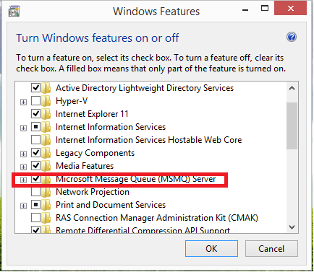
2.2.2 How to check the MSMQ exist?
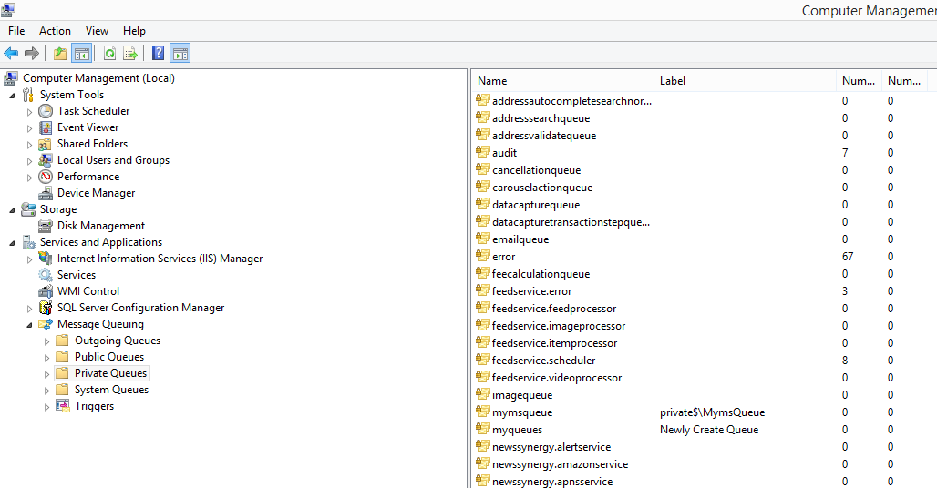

2.3 Code
- Controller/MessmgeController.cs (export api) : send the model to msmq.
- Msmp/MsmqTransactionInfo.cs : Receive msmq and call the logic.
- BusinessLogic/*.cs : database operation.
- Web.config: Configure the msmq.

3. The composition of data capture.

